Metadata Guidelines for the UCLA AIDS Poster Collection

Angela Riggio & Luiz Mendes
Mar. 2006 rev.
Revised January 20, 2008 by John Riemer & Lisa McAulay

Introduction

The VRA Core Categories version 4.0 was the metadata standard used to describe and analyze the first part of the AIDS Poster Collection in 2006.

The VRA standard calls for two records to be created for each poster: a work record describing the physical characteristics and subject of each poster, and an image record describing the physical aspects of the digital image of each poster. In practice, all of the descriptive metadata created related to the work record. As the data was migrated to the new Digital Library Collection System (DLCS), the descriptive data and the image comprise one record. If necessary, the metadata for this collection can be output in a VRA format. The DLP and the DL programming team plan to work on providing this feature in the near future.

The Cataloging & Metadata Center is responsible for the descriptive metadata for each poster and the Digital Library Program is responsible for the technical metadata.

It is important to note that all elements of the VRA Core 4.0 set are repeatable and optional. However, not all VRA Core elements have been used in this project. In DLCS, though, the element “Title” is not repeatable.

The Metadata Data Elements & Procedures table below should be used as a general guide and procedure for inputting data into DLCS for the AIDS Posters collection. The fields below are in the order as they appear in the DLCS.

AIDS Poster Collection in DLCS (Login Procedures)

UCLA Digital Library Program

URL: http://digital2.library.ucla.edu/dlcs
Username: [your full email address]
Password: [initially 123456 until you change it]
After gaining access, then
Choose: AIDS Poster Collection [and click Submit button]
DLCS accounts for Cataloging and Metadata Center staff are in the category of “Data Entry.” A data entry account has the ability to create and delete descriptive metadata and to create, edit and delete control values. If there are any problems with your account, please contact Claudia Horning (CMC troubleshooting and service improvement rep) and/or John Riemer, (project manager in DLCS for metadata creation).

Note: Please use only the Internet Explorer browser for DLCS. Others like Firefox have not been tested.

Metadata: Data Elements & Procedures

Data Element | Notes & Examples
Title | Title is not repeatable. Use Alternate Title for variants. Overwrite the provisional Title initially assigned to the poster, e.g., “. new US057” (United States)  Transcribing Titles:  Prefer using selected text on the poster for the Title  - Select words found on poster as a formal title (if no wording is suitable for such a title, devise a title as instructed below.)  Beware of “campaign slogans” and text presented as part of a “story” or “situation.”  - Transcribe titles with the punctuation found on poster (do not add ISBD punctuation)  - Omit initial articles  - Currently DLCS does not support qualifiers for Title. Add following the transcribed Title: [inscribed]  Devising Titles:  When there is no text on the poster, or when the text is not suitable for Title, devise a title:  - Devise a brief descriptive title including identification of subjects depicted (i.e., objects, events, activities). Capture both aspects of subject in devised titles, i.e. “of” and “about.”  - Add following the devised Title: [descriptive]
Alternate Title | - If the Title (inscribed) is not in English, supply a translation of Title as Alternate Title.translated. (No need to enclose translated titles in brackets. If a poster provides the title in multiple languages, add each one not selected as Title as an Alternate Title.inscribed, not translated.)  - Code transliterated titles as other.  Some posters are issued as a group, and carry the same “series-like” phrase/title. These are usually the slogan for a campaign:  I care... Do you?  A mí me importa... Y a ti?  America responds to AIDS  America risponde al SIDA  Protégez-Vous!  Stop AIDS  Record the phrase as Alternate Title in order to provide access under the slogan/campaign “title.” Record title in the language inscribed on poster. Code it as Alternate Title.other  - Also use the “Description” field to indicate poster is part of campaign:  Part of “America responds to  AIDS” campaign.  Part of “Stop AIDS” campaign.
Alternate Identifier | The initial (placeholder) Title has been replicated in the Alternate Identifier field, with the qualifier ”.local”. It consists of two or three letters representing the place of origin followed by a sequential number for that place, e.g.  Alternate Identifier.local: US057.
[Identifier] | Input/edit capability for the URL is not available in DLCS. The distinctive, final part of the URL is assigned internally and displayed at the top of the record. (The full URL is an ARK, or Archival Resource Key)
Subject | Subject is a controlled element in the AIDS posters collection. This means that all values for this element must be selected from the drop down menu on the data entry screen for an item. If the value you want to assign is not available in the drop down, you will need to add the value to the project using the “Control Values” link on the top navbar. See Appendix.  Perform subject analysis of the poster contents to determine the most appropriate headings and terms. Choose a qualifier from the dropdown menu:  - conceptTopic (about)  - descriptiveTopic (of)  - personalName  - corporateName  - geographicPlace  - Use TGM I for indexing what is depicted in the poster, covering both “ofness” & “aboutness”  TGM I  http://www.loc.gov/rr/print/tgm1/  If no term is available in TGM I, assign subjects and code SOURCE for controlled vocabulary as “local”  - Use LCSH & MeSH to index the overall AIDS-related purpose of the poster (e.g. AIDS prevention, AIDS discrimination, HIV infections, HIV testing, etc.)  LCSH  http://authorities.loc.gov/  MeSH  http://www.nlm.nih.gov/mesh/MBrowser.html  - For names and geographic to be assigned as subjects, use LCNAF. Formulate headings not represented in LCNAF according to AACR2R.  For subdivisions, close up the spaces on each side of the double hyphens.  See Appendix on how to “Control Values” in order to set up/create new terms for use.  (On the Data Entry screens, one can see all of the terms, but not an indication of which controlled vocabulary they belong to. This is a programming fix the DLP plans to make.)
Agent | This element is both qualified and controlled.  Each instance of this field will consist of two parts. One is the name (the value) of the person/body associated with the work; the other is the relator term (the qualifier) that describes the role the person/body played in the creation, design, production, etc. of the work. Both operate using pull-down menus.  - Use the LC Authority File to check the form of personal and corporate name headings.  - Construct the Name according to AACR2R when no authorized form exists.  - Omit subfield codes and delimiters that would be used in MARC 21 data.  If the name you need to enter is not available on the data entry screen in the drop down for name, you will need to add the control value and enable it for the AIDS Posters collection. See Appendix on “Control Values” at the end of these guidelines.  To record the role for a Name, use the box at the left. Pull down the list under “Please select qualifier …”  - The authorized list of roles is the “MARC Code List: Part I: Relator Codes.” This list includes helpful definitions and can be found at http://www.loc.gov/marc/relators/relators.html  - For terms needed that are not in the DLCS pull-down list, they need be added by DLP programmers, via a request to Claudia or John.  For each poster the name of the poster repository has been pre-populated:  Agent.repository: Louise M. Darling Biomedical Library. History & Special Collections  Select from the list of roles terms such as the following when the information is available on the poster: artist, conceptor, creator, designer, photographer, publisher, sponsor.
Description | Use Description.note: to provide a description of the poster and to record contents, both “ofness” and the “aboutness” of the poster—especially when these might not be fully addressed through the use of controlled vocabularies (TGM, LCSH). Some guiding questions: What is (are) the image(s) of? What does it (do they) suggest?  The record for each poster will contain a Description field indicating the physical location of the original object within the special collections at the Biomedical Library. (Staff at that library will create this metadata for the project.)  Description.note: Poster held by Louise M. Darling Biomedical Library. History & Special Collections, Collection no. 306, item GW039.  Use Description.inscription: as appropriate, to record text extracted from the poster; translation of text; and other inscriptions found on item (marks, caption, etc.). Precede notes with labels suggested here, when appropriate:  - Additional poster text:  - Translated poster text:  - Translated additional poster text:  The Additional poster text label should be used if some part of the text was extracted as a Title or Alternate title.  Description.inscription will contain the wording found on poster. Data on posters containing non-Romanized characters should be transliterated as well as transcribed.  Use judgment in deciding how much poster text to transcribe (and to translate), especially for posters which are mainly textual.
Publisher | This field is used only to record the place of origin for the poster. The publisher itself should be recorded in Agent, as Agent.publisher.  Publisher.placeOfOrigin: Atlanta (Ga.)  The value you enter here should be according to AACR2, as opposed to the value for Coverage.geographic, which should use the name of the country of origin.
Date | Provide the publication or copyright date in this field.  Date.publication: 1998  Date.publication: c2002  If the date is not present on the poster and consequently is taken from other sources or inferred, supply the date or date range in brackets.  Date.publication: [2002?]  Record the date of publication (or the range of possible dates). For the latter, staff at the Biomedical Library will sometimes have information that will help limit the range.  Description.note: Date on back of poster, 2004, reflects when the vendor received the copy later acquired by the UCLA Library.  Date.publication: [between 1987 and 2004]  In addition to Date.publication also provide the date information in the form of a normalized date. Date.normalized is based on the ISO 8601 standard, which provides dates in the format YYYY-MM-DD. The advantage of the latter is that dates in normalized format are more readily manipulated by machines for searching and limiting.  Date.publication: c2002  Date.normalized: 2002  Date.publication: [between 1987 and 2004]  Date.normalized: 1987/2004
Type | The data entry screen will be pre-populated with these two fields. Nothing additional is needed.  Type.genre: posters [from AAT, for original object]  Type.typeOfResource: still images [from MODS, for digital object]
Format | Format.dimensions is used to record the size of the original poster in both metric and U.S. units. The latter is captured during the digitization process.  Use the conversion table below to supply the metric units. It is based on http://www.sciencemadesimple.net/length.php  Format.dimensions: 28 x 36 cm. (11 x 14 in.)  (If the measurements in centimeters are not available at the time of metadata creation, assumed that the information will be provided later by staff in the Biomedical Library and that DLP students will provide the conversion to inches.)
Language | Provide the (primary) language of the poster text in the form of the 3-character abbreviation. Use the MARC Code List for Languages at http://www.loc.gov/marc/languages/langhome.html  Language: dut  If there is no linguistic content on a poster, use code zxx.
Coverage | For this project, Coverage.geographic is being used to provide browsing by the country of origin for the poster.  Coverage.geographic: Canada
Rights | Rights metadata will be provided by staff in Digital Collection Services.

Entry of Diacritics and Special Characters

Choose one of the following methods:

1) Copy and paste characters from the Unicode Tool

2) Copy and paste text from Connexion or the LC authority file at http://authorities.loc.gov

Reference Sources

A good data source for supplied titles, descriptions, translations of text, ideas for subject analysis, etc. for some posters is the Core Initiative site, at: http://www.coreinitiative.org/Resources/Materials/index.php

Statistics

Currently there is no easy automated means of tracking the statistics of completed posters. Individuals’ stats will be reported out when the project is completed.

Conversion Table for Format.dimensions
(http://www.sciencemadesimple.net/length.php)

Inches (in.) | Centimeters (cm.)
11 | 28
12 | 30
13 | 33
14 | 36
15 | 38
16 | 41
17 | 43
18 | 46
19 | 48
20 | 51
21 | 53
22 | 56
23 | 58
24 | 61
25 | 64
26 | 66
27 | 69
28 | 71
29 | 74
30 | 76
31 | 79
32 | 81
33 | 64
34 | 86
35 | 89
36 | 91
37 | 94
38 | 97
39 | 99
40 | 102

Titles: Some Additional Observations

“In poster cataloging, ... the title is often composed and printed in a variety of type faces and sizes; the important elements intended to catch the viewer's eye from a distance, with the full title only becoming clear as one approaches the poster for closer scrutiny.” (LC Prints & Photographs Division)

Some additional characteristics of titles on graphic materials: Title elements may be scattered over the item; arranged decoratively; composed of images and words; presented in multiple languages. Some titles may be long; others abbreviated; and there may be separate titles for discrete images on item. Or, titles may be insufficiently descriptive. Or, there may be no titles.
(Adapted from Graphic Materials: Rules for Describing Original Materials and Historical Collections).

Cataloger must decide whether printed text (if any) constitutes a title. Follow the approach below:

  - Consider candidate wording for title based on prominence and uniqueness.

Note, however, that prominent wording on posters does not always qualify as Title, as illustrated by posters where the prominent wording form part of the text (i.e., beginning of narrative of “story” presented, as illustrated by poster below)


Derek lost his entire family to AIDS.
One year later,
they are still not talking to him.
That’s why he called us.
We always listen. We never judge...
(United Kingdom poster: UK20)

In this example, the prominent text was judged short enough to make a suitable choice for Title.
Title: Derek lost his entire family to AIDS. One year later, they're still not talking to him. [inscription]
Alternate Identifier.local: UK020



In the above example, the length of the text in white led to a decision to supply a Title and to transcribe the text in a Description field:

Title: Poster with message from Jon Secada [descriptive]
Alternate Identifier.local : UNA06
Description.inscription: El VIH/SIDA es una enfermedad que tiene muchos rostros. Muchas personas viven con el estigma asociado a su condición. No discrimines. Vive y dejar vivir!

Note also that wording on posters need not be unique to be considered a Title, as illustrated by the sequence of posters below where the “prominent” text represents the campaign Stop AIDS and its Spanish equivalent Stop SIDA.


(Switzerland posters)

Description & Subject Analysis

Description
Use the Description element to provide a note about the subject(s) depicted. (Do not use label “Subject.”)

“Use this note...for an objective narrative summary of a collection or for clarification of the content, meaning, or iconography of a single item. Information that places the material in a proper context and conjectural statements may be included. Extrapolations, conjectures, and educated guesses should be clearly indicated by wording or a question mark.”

(Note: Follow procedures outlined above for additional Description elements.)

Subject Analysis

Assign index terms that describe “what the image is of” as well as “what the image is about.” For this project, follow the procedures outlined above:

Use Thesaurus for Graphic Materials I: Subject Terms for indexing both ofness and aboutness.
  - Assign terms missing from TGM I at the level of specificity appropriate to subjects depicted.
  - Use LCSH & MeSH for overall poster purpose and subject
  - For name (personal, corporate) and geographic headings, use Library of Congress Name Authority File

Note:

- Index “images of” (depicted) not captions of images
image of “mosquitoes” vs. caption “insect bites” → Mosquitos [TGM]
image of a “toilet” vs. caption “public restrooms” → Toilets [TGM]

- Depth of indexing: In a poster such as “Hey! You know what? You can't get AIDS from...” (US037), it is not necessary to provide a subject term to cover all the depicted means by which one cannot get AIDS.

[See Introduction to TGM I: http://www.loc.gov/rr/print/tgm1/toc.html]
References
Parker, E. B. (1982). Graphic Materials: Rules for Describing Original Items and Historical Collections. 1982. Updated in August 1997 on the Cataloger's Desktop.
Appendix:
Working with Controlled Fields in DLCS
Overall summary of procedure:
    - For any data element that is controlled, first try to locate the term in a pull down list on the Data Entry screen.
    - If it is not there, use the navigation bar to go to the Control Values screen. Look to see if the heading has been used for another digital library project and authorize it for use in this project.
    - If the term cannot be found in DLCS, consult outside sources to find the established heading or term. If not found, use rules and guidelines for formulating new headings and enter in DLCS via Control Values screen.
    - Make screenprints of any new name or subject added to DLCS and pass along to the Authority/Database Maintenance Section for their review.

Detailed procedures:
- Look for the term in the pull-down list available on the pull-down for the applicable data element on the Data Entry screen. Example, for Subject:
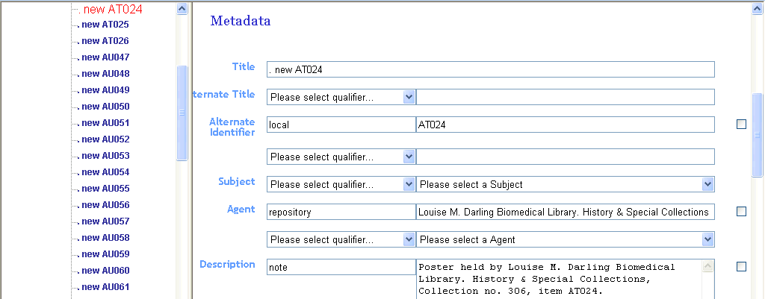
For ease of entering the list at a particular point in the alphabet, enter the initial character of the term you are looking for. Enter that character multiple times to move down the alphabetical list.
If the term is found, click on it once to enter it in the Data Entry box, in place of “Please select a Subject.”
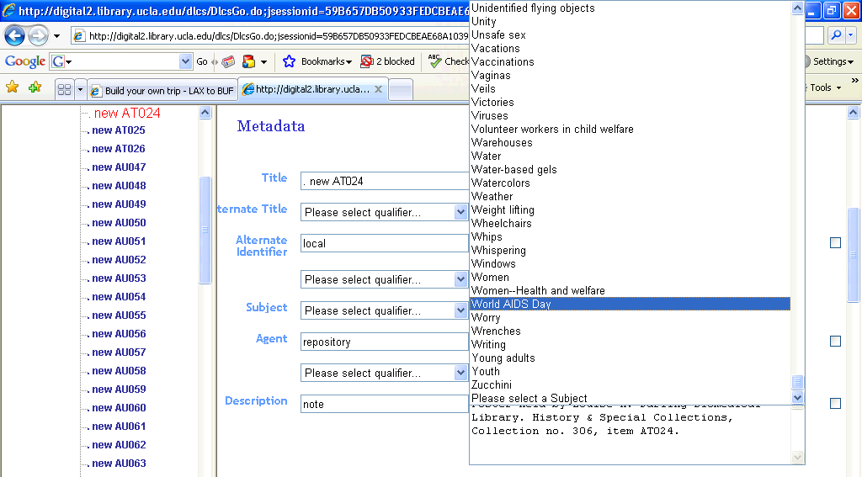
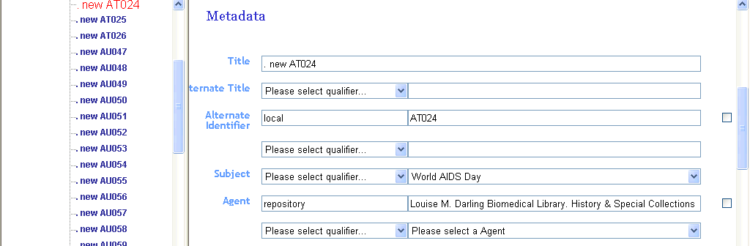

2. If the needed term cannot be found, first hit the “Save” button at the bottom of the screen to preserve your work up to this point. Then look for the “Control Values” link on the navigation bar across the top of the Data Entry screen:
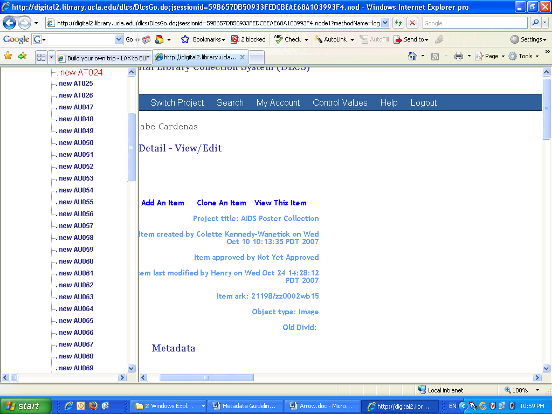

Move to the Control Values screen:
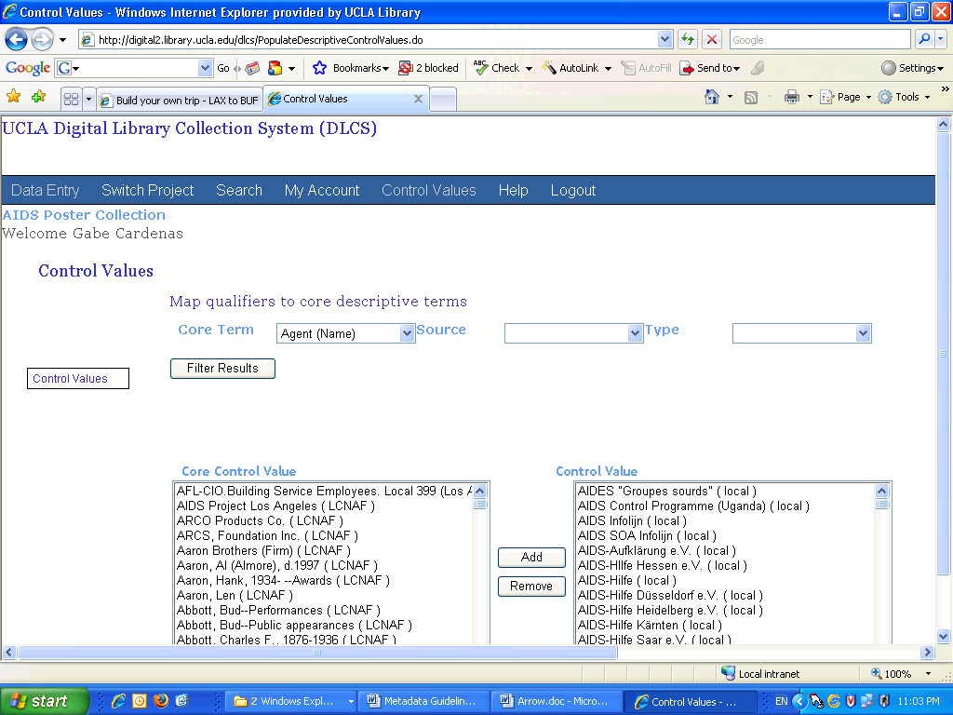
The default list will be Agent (Name). Use the pull down for “Core Term to select another list, e.g. Subject:
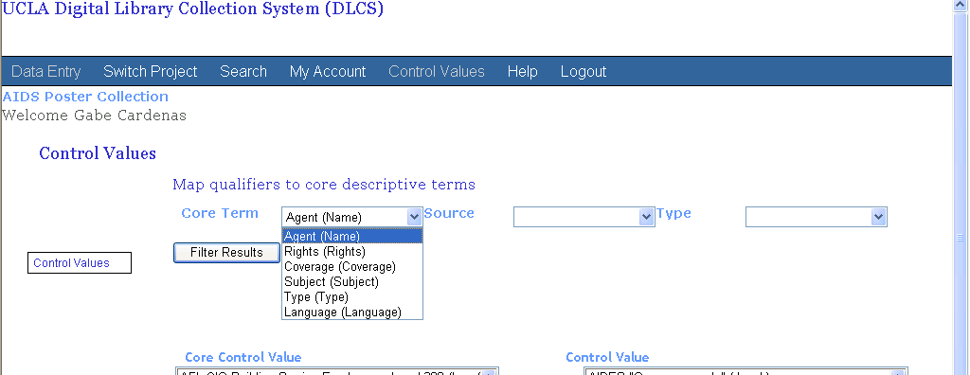
Highlight the list desired and click on the “Filter Results” button to change lists.

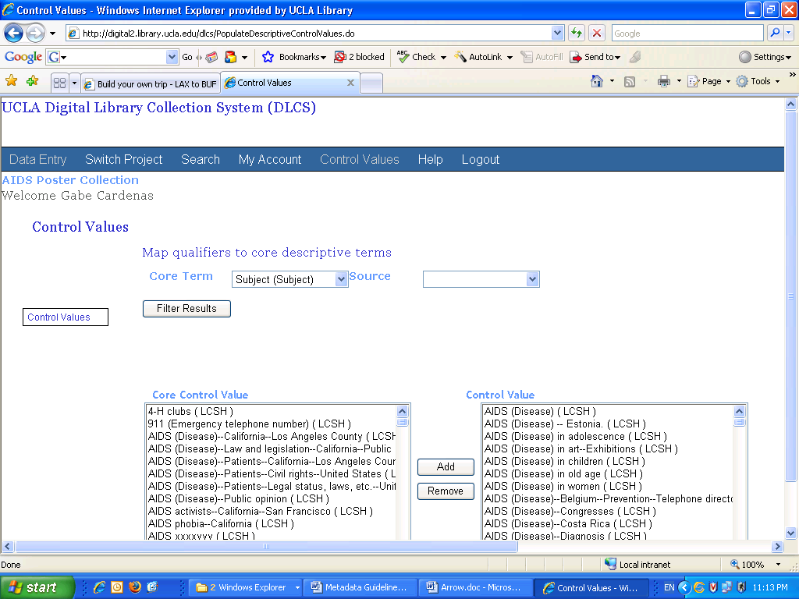
The pull down list under Source can be used to filter to a list of terms from only one particular vocabulary:
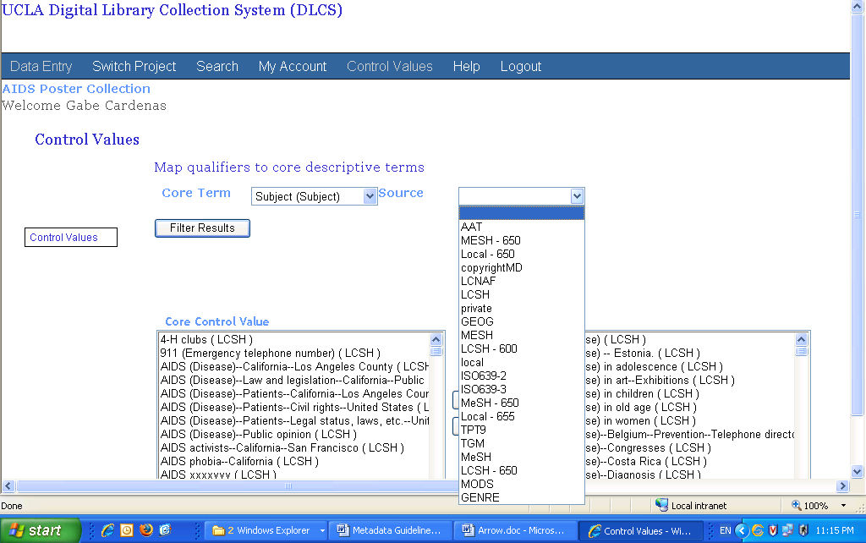
The list on the right side under “Control Value” represents every Subject already authorized for use in the project. Those terms are what DLCS makes available in the pull down list on the Data Entry screen cited earlier.
The list to the left under “Core Control Value” represents all the terms authorized for use in at least one other digital library project. To add a term to the current project, highlight the term on the left and click the “Add” button in the middle of the screen to move it from the left list to right list.
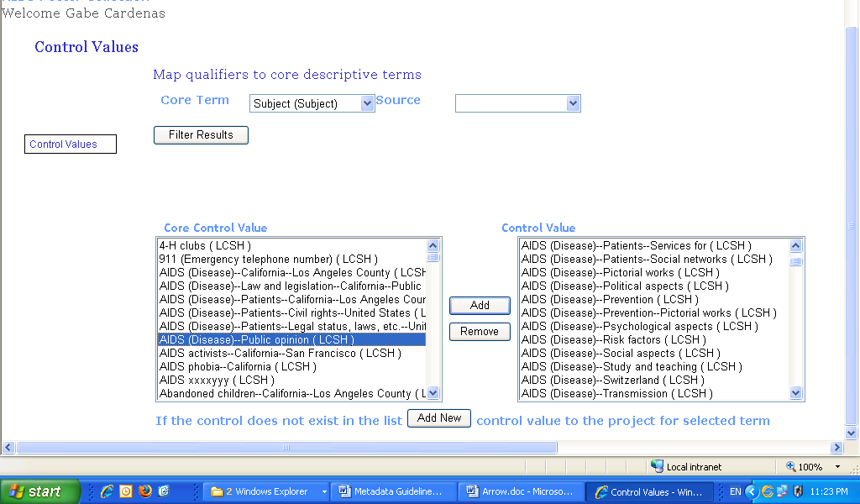

3. If the desired term is not available yet in the “Core Control Value” list, find it in the appropriate thesaurus or authority file. Then click the “Add New” button to receive a pop-up window for adding new terms to the list:
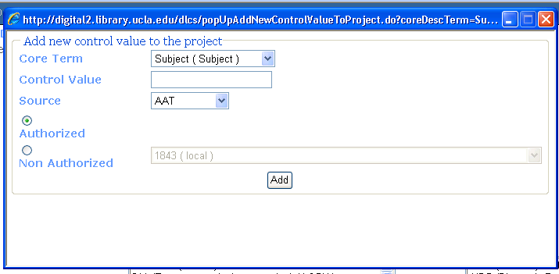
Fill in the term in “Control Value.” Select the applicable vocabulary under the pull down list for “Source.” Choose the Authorized/Non-Authorized radio button. Click on the Add button.
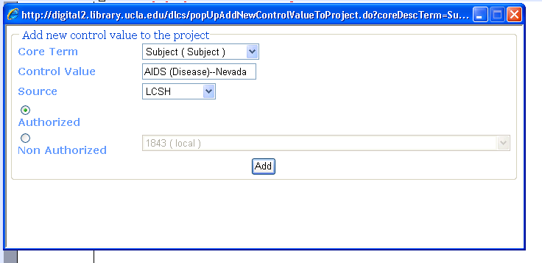
Pressing the Add button will send the new term directly to the Control Value list on the right side of the screen:

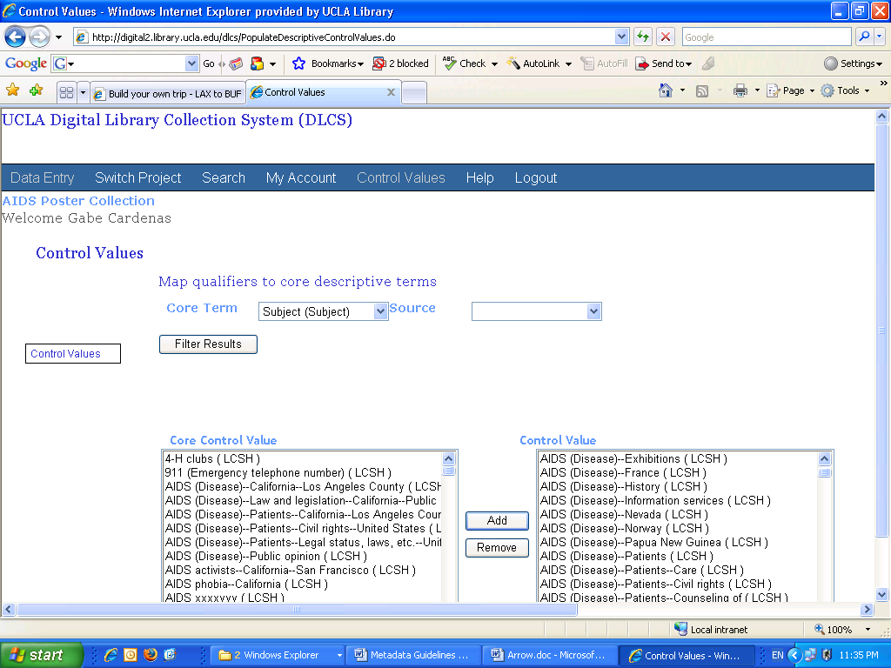

4. Make a screenprint of any new name or subject added to DLCS and pass along to the Authority/Database Maintenance Section for their review.

Return to the Data Entry screen via that link in the navigation bar at the top of the screen. The record you were last editing will appear highlighted on left-side navigation pane.
On the Data Entry screen look for the newly-established term in the pull down list and assign it to the image.
Repeat these procedures as often as necessary to cover all the controlled terms needed.
Note: The indexing of new terms is relatively quick but may not be immediate.

Please change your password after your first log in. To do this, look for the “My Account” link at the top of the screen.
If you forget your password, John Riemer, Claudia Horning, or anyone in DLP can reset it for you.

